Phase 2:
1-System Architecture
This shows the four-layer structure: the Presentation layer (what users see), the Controller layer (handling requests), the Service layer (with the Recommendation Engine as a separate module), and the Data layer.
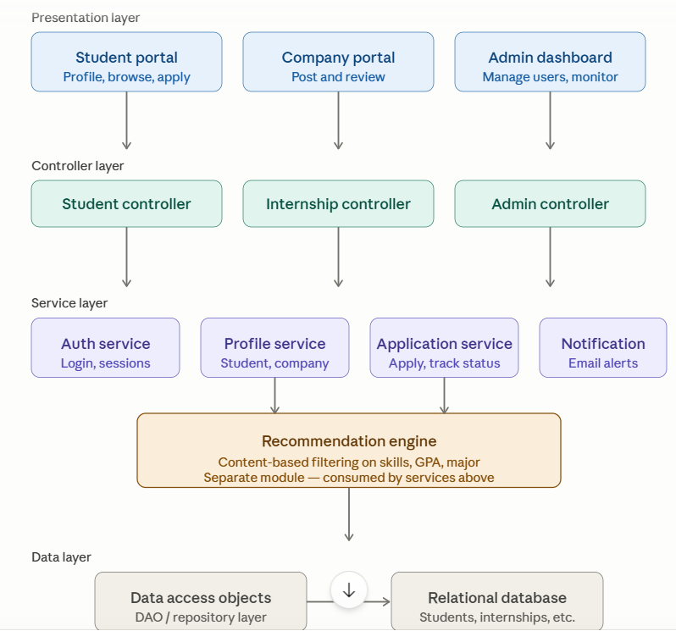
Figure 1: Layered MVC architecture

2-Class Diagram
The following class diagram illustrates the static structure of the system, showing the main classes, their attributes, methods, and the relationships between them. It provides a clear overview of how the system is organized in terms of object-oriented design.
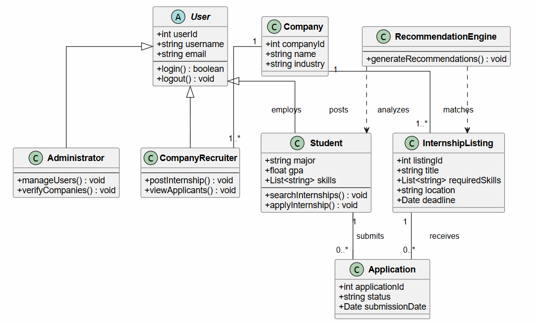
Figure 2: Class diagram

3-ER diagram
The following Entity-Relationship (ER) diagram illustrates the database structure of the system. It shows the main entities, their attributes, and the relationships between them. This diagram helps in understanding how data is organized and connected within the system.
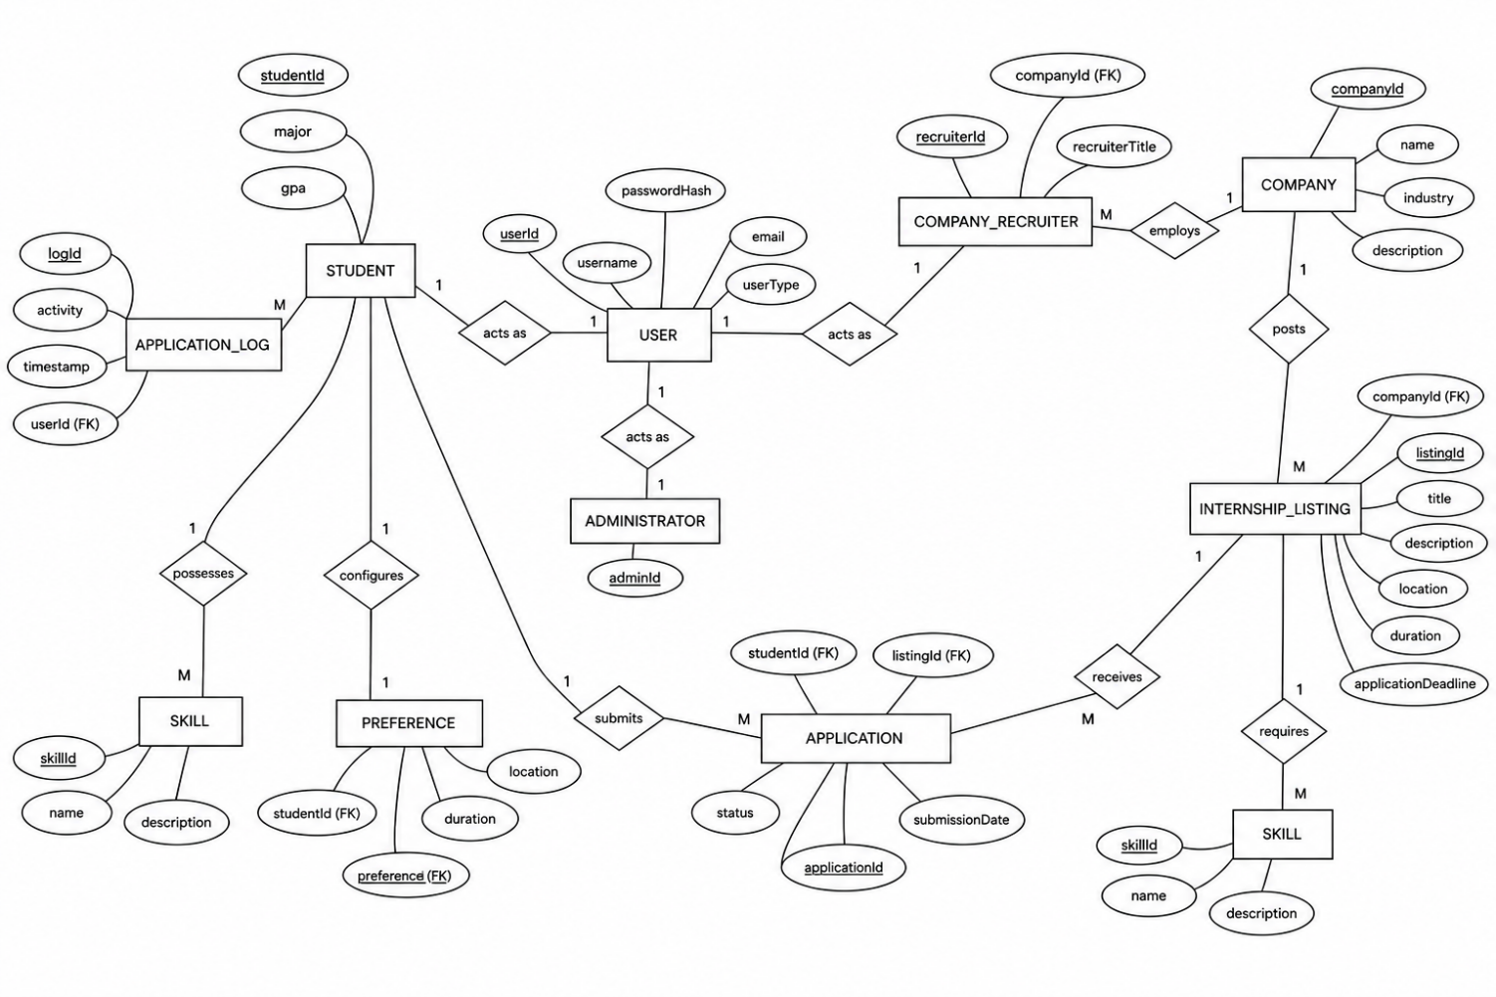
Figure 3: ER diagram

